This is the gallery (museum’s Rotuonda) it will be used as the designted area for the assignment). the scellepture will be in the center of the gallery. This picture shows on of the four acloves that designend in the gallery, where we going to display the objects.
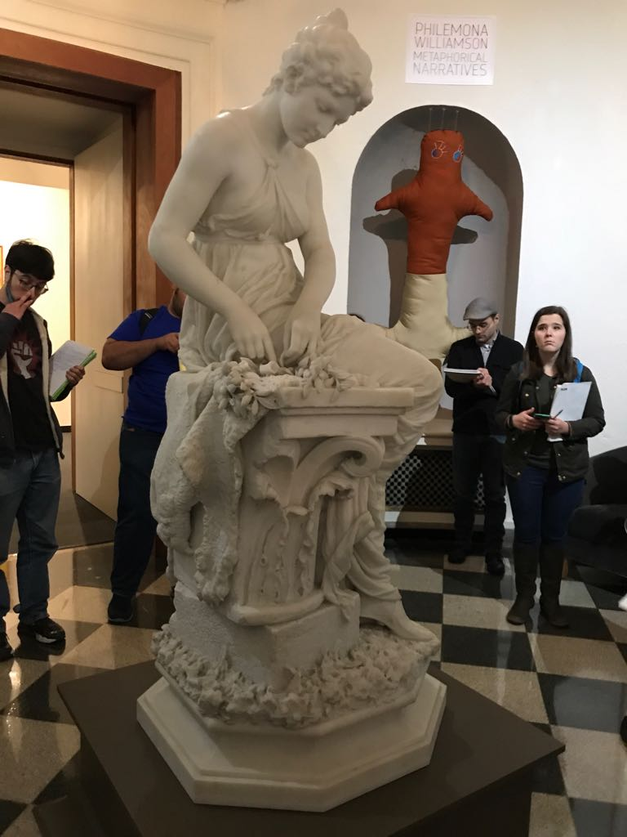

Daigram for the gallery and acloves.
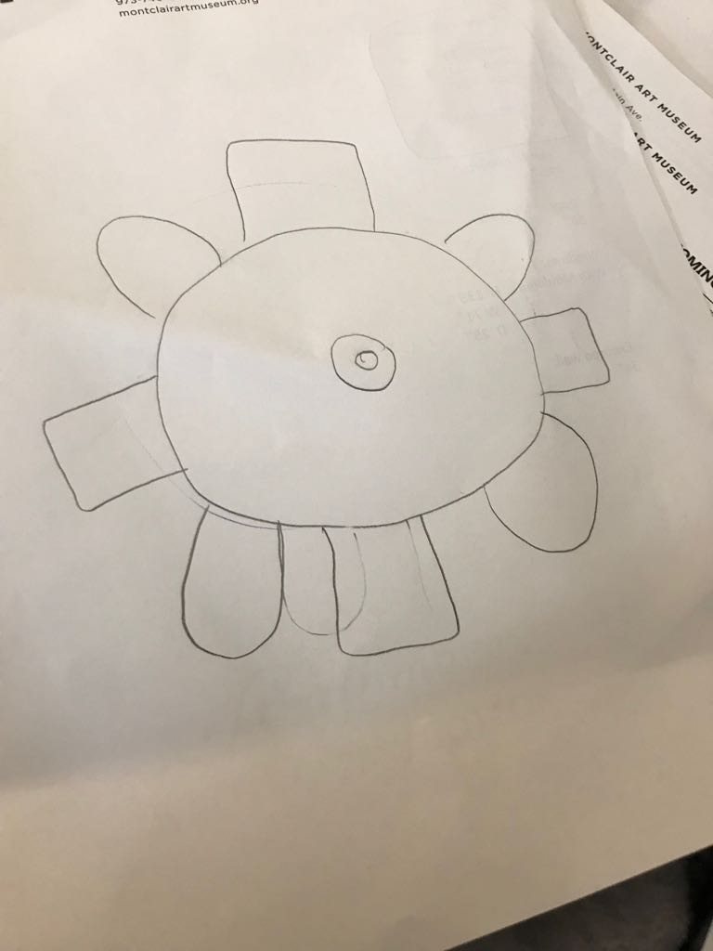

This is one of the architectural acloves where the objects will be displayed.
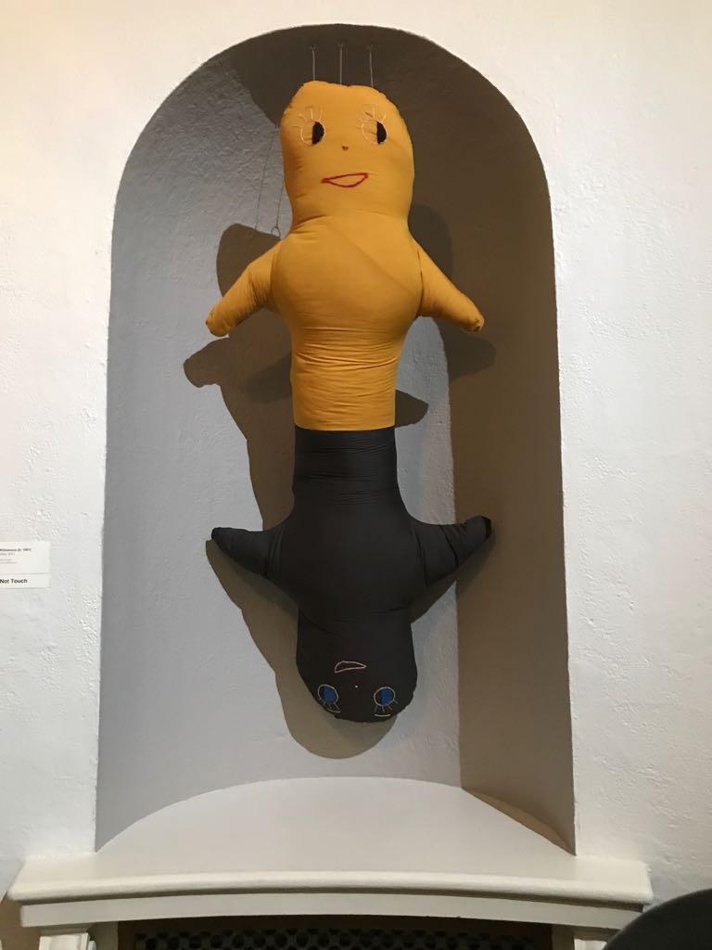
FORM OF THE LOAN AGREEMENT
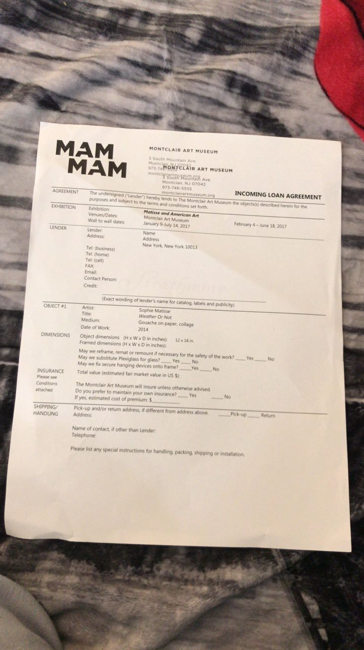

FORM OF THE CERTIFICATE OF INSURANCE
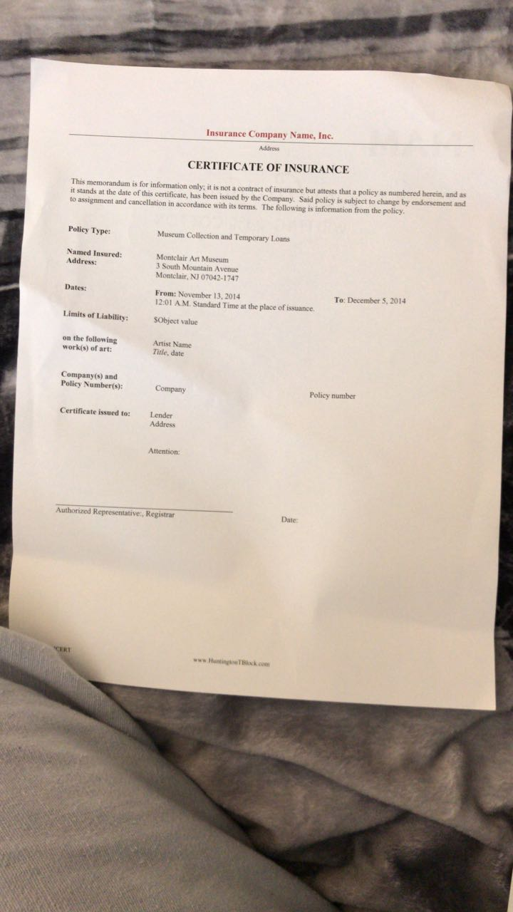

The assignment instruactions Page 2
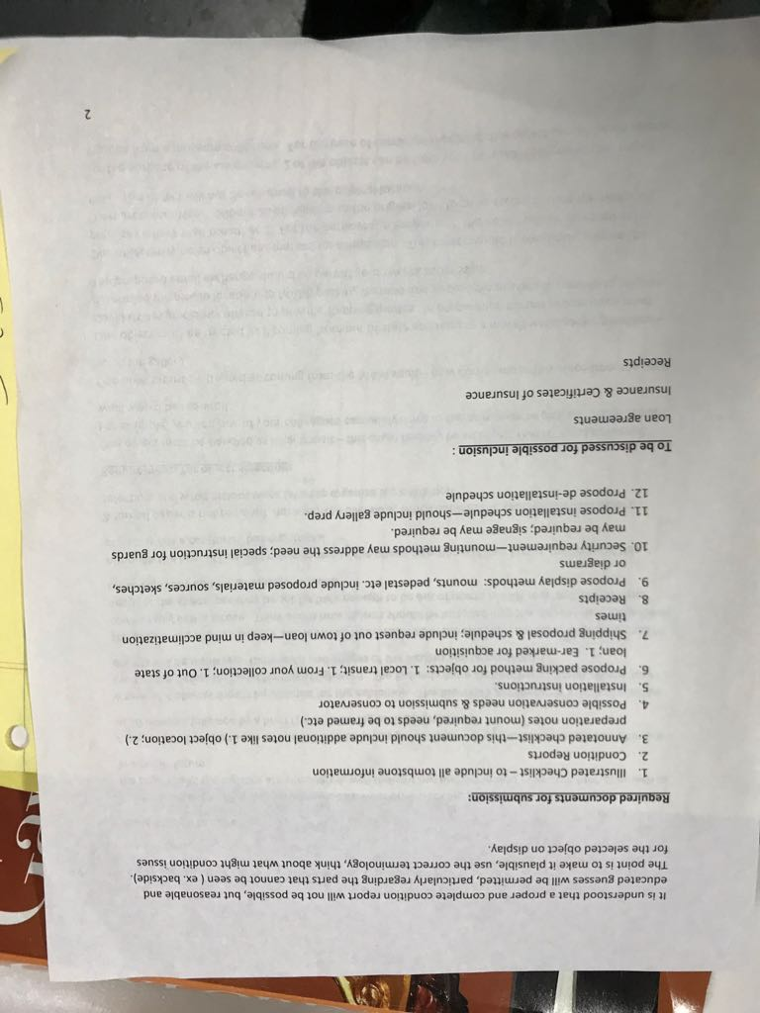
The assignment instruactions Page 1

